# Assignment -3

**Build CNN Model for Classification Of Flowers**

|  |  |
| --- | --- |
| Assignment Date | 06 October 2022 |
| Student Name | Prakash S |
| Student Roll Number | 113219041085 |
| Maximum Marks | 2 Marks |

## Download the Dataset : Dataset

Dataset downloaded and uploaded

## Image Augmentation

from tensorflow.keras.preprocessing.image import ImageDataGenerator daisy_datagen=ImageDataGenerator(rescale=1./255,zoom_range=0.5,horizont al_flip=True,vertical_flip=True)

x_data= daisy_datagen.flow_from_directory(r"/content/drive/MyDrive/flow ers/daisy",target_size=(64,64),class_mode="categorical",batch_size=24)

x_data.class_indices

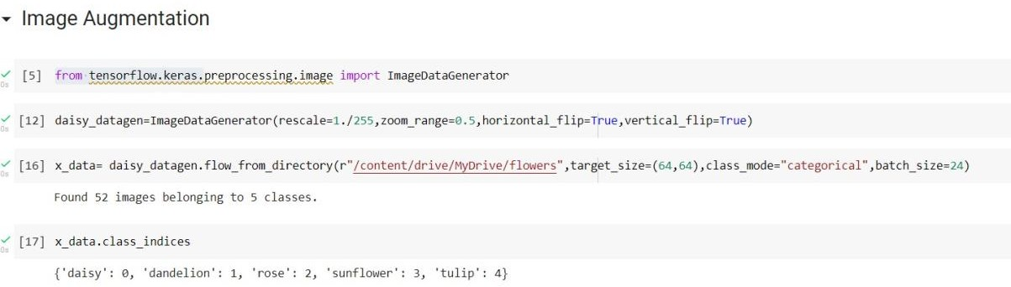

## Create Model



1. **Add Layers (Convolution,MaxPooling,Flatten,Dense-(Hidden Layers),Output)**

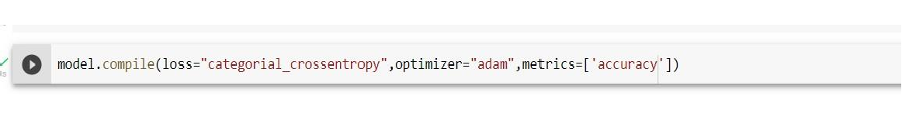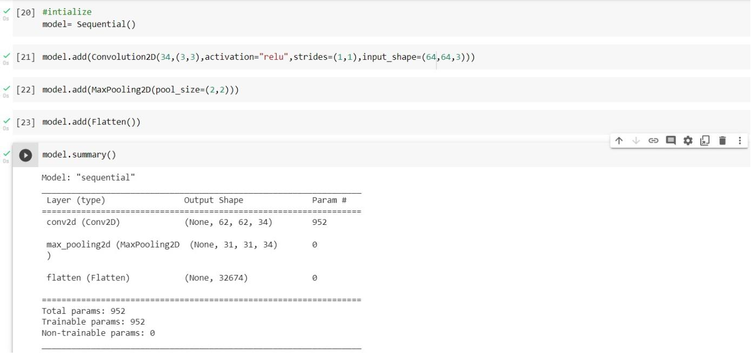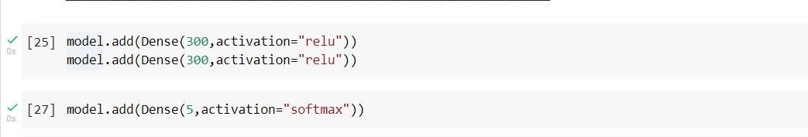

1. **Compile The Model**
2. **Fit The Model**

model.fit(x_data, epochs= 10, steps_per_epoch= len(x_data) ,validation_ data=0.0,validation_steps=0.0)

## Save The Model

1. **Test The Model**

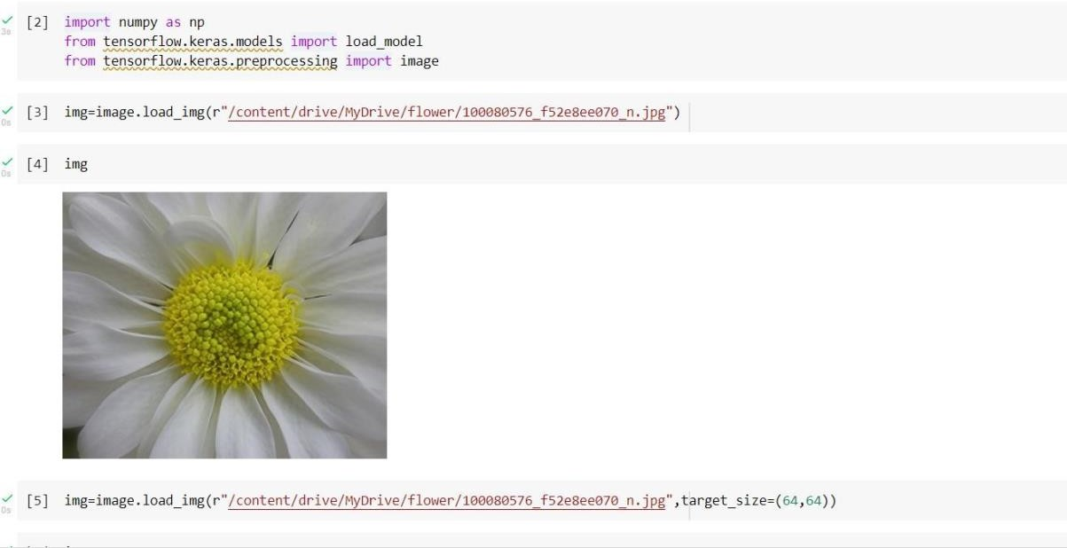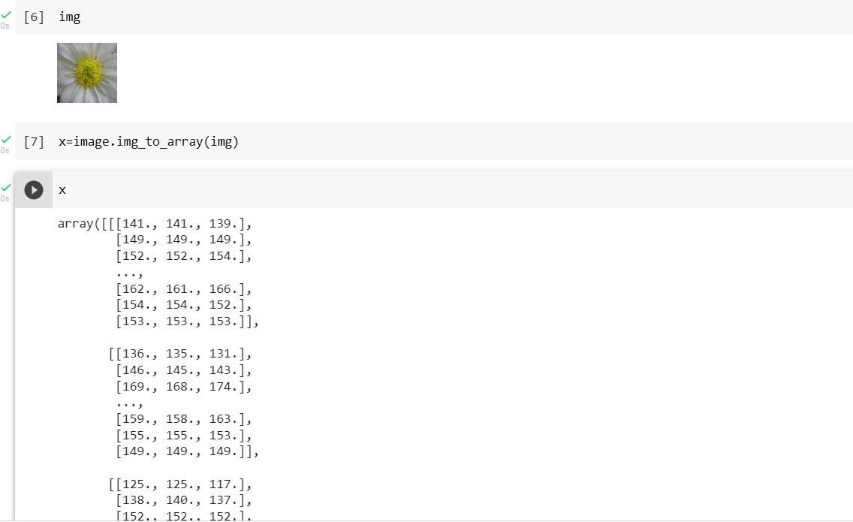

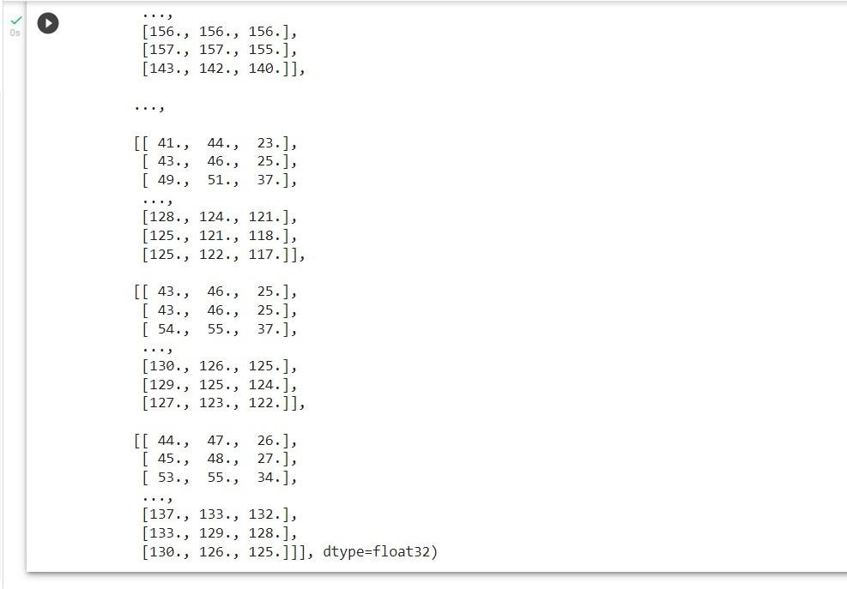

x=np.expand_dims(x,axis=0) pred= model.predict(x)

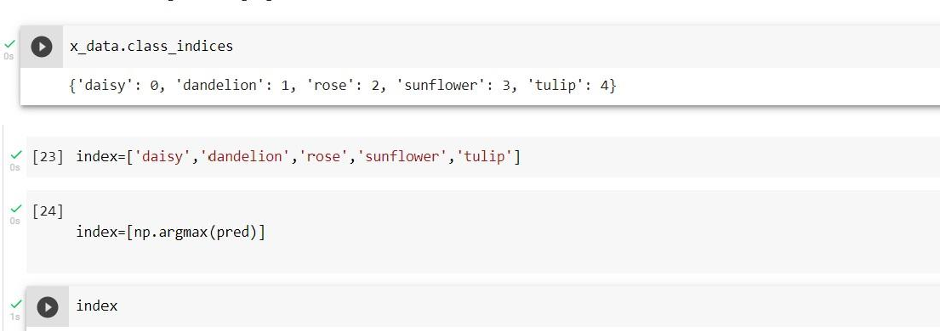

x_data.class_indices

‘daisy’